**Quick guide to Notices on OLE** (v.03/02/2020):

* Brief, relevant and timely messages to the intended audience only.
* Select relevant Audience, Topic and Publishing Dates (screen shots and more detail below).
* Not meant to be used for ongoing communication with teams or groups. Students and parents should be directed to the group’s OLE page for regular info.
* Nor to be used to highlight/promote activities not related directly to our schools.

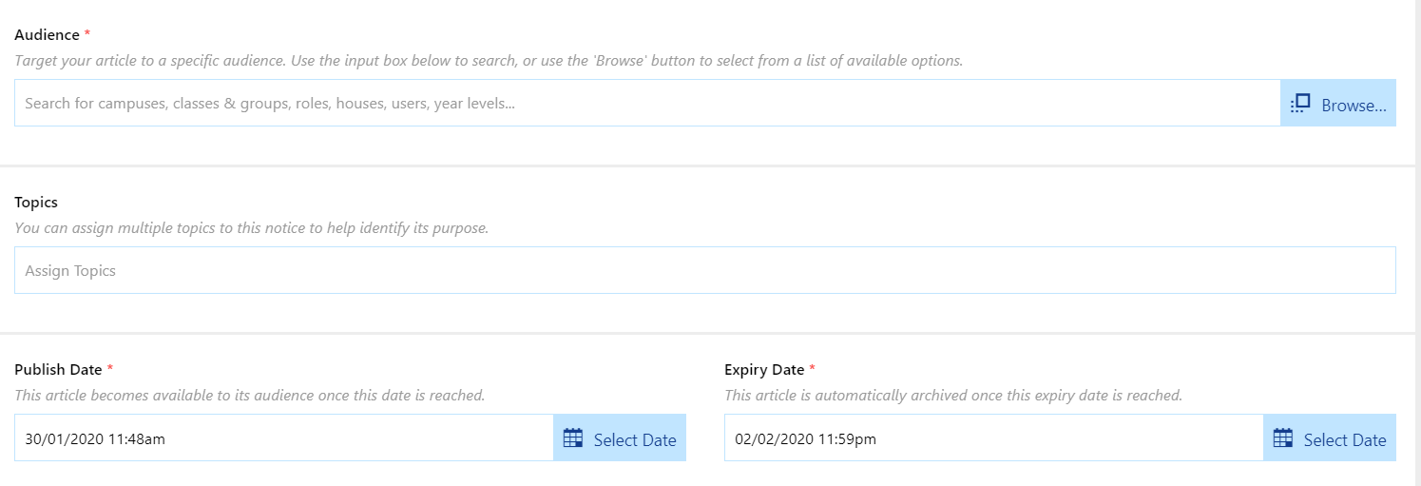

**Audience** – **use Create Composite Audience every time.**

* Audience Type 1 specific to who needs to see it only.
* Audience Type 2 select SKC as campus

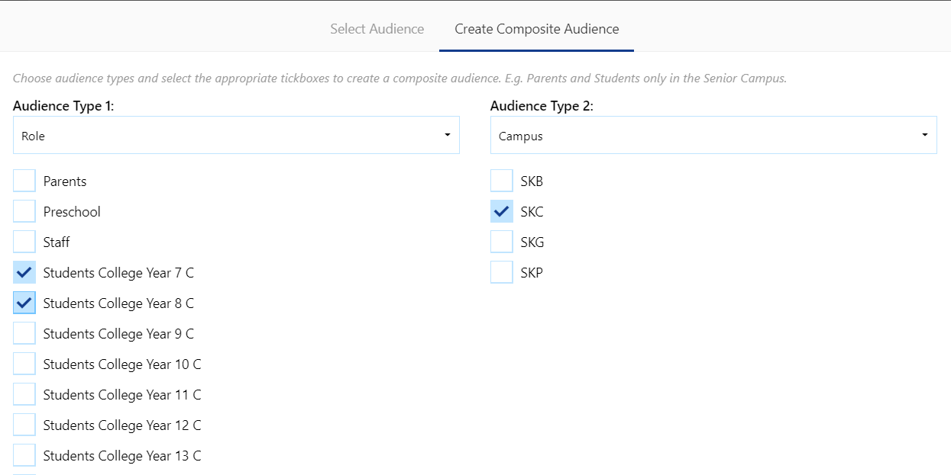

**Topics – categorises where it shows in the notices.** You can select multiple categories if it is appropriate.

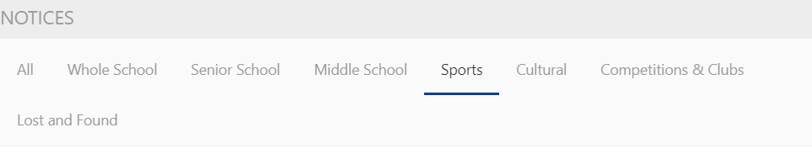

**Publish Date/Expiry Date** – make the expiry date tight so the notice comes down as soon as it is no longer relevant to keep down the clutter of notices. Youcan also pre-load notices to go live at the time needed.