**Saint Kentigern College Student Learning Conferences:**

**Caregiver Login & Booking Instructions**

Please follow the instructions below to book your child’s or children’s conference time.

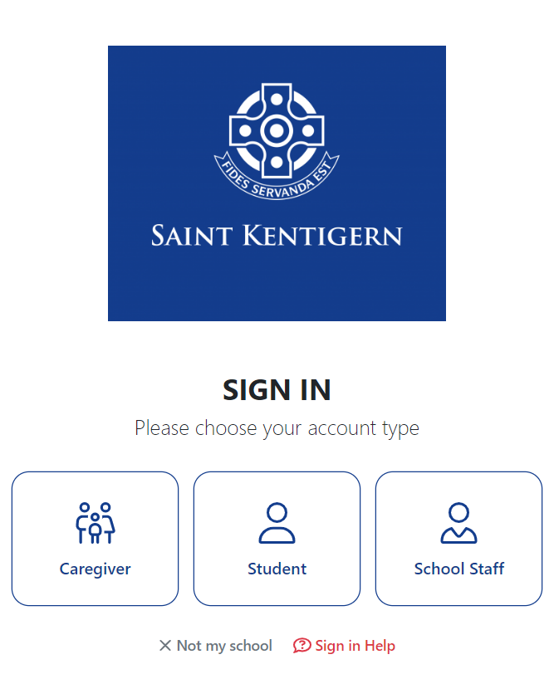

Parent/Caregiver Login

If the email you have registered with the school is a **Google** or **Microsoft** Email (ie. Gmail or Hotmail), you will simply “Request Sign in Code”. Click on the Login button to go through to start your booking.

**Login instructions for Google or Microsoft Emails below   
(ie Gmail or Hotmail)**

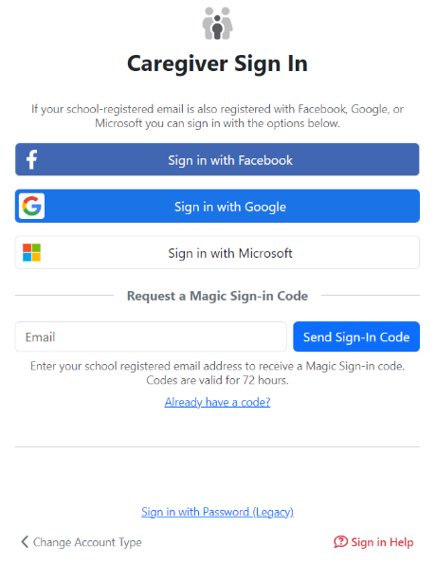

Login for Google or Microsoft Email

If the email you have registered with the school is another email provider (ie. Xtra.co.nz, icloud.com or yahoo.com) you will need to select “Request Sign in Code” **then go back to your email inbox where another email will have been sent to you from and click on the Magic sign in code to login (see example below).**

**Login instructions for other email address providers   
(ie Xtra.co.nz, icloud.com, yahoo.com)**

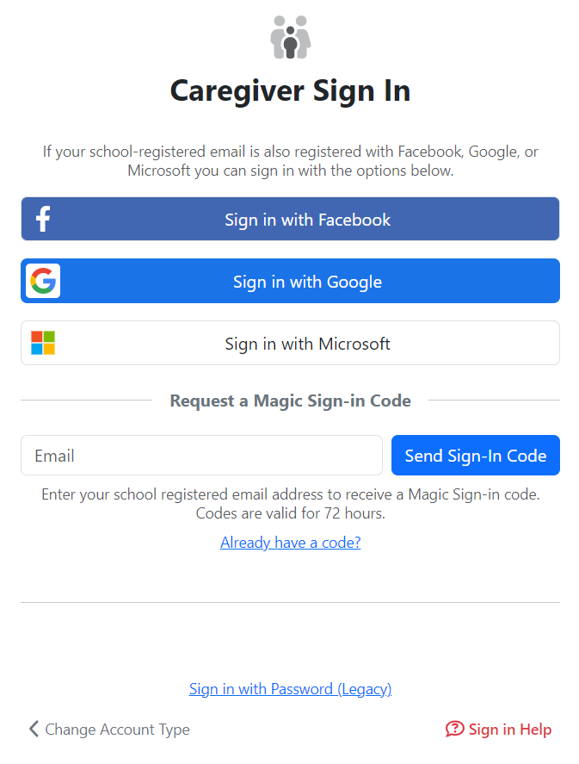

Your registered Email address will be populated here.

Click here to receive your code. Go back to your email inbox and use your Magic sign in code to start booking.

Oncelogged in, select your child (if you have more than once child you will need to complete individually ie. Once one booking is complete, go back to the homepage and repeat steps – note to not double book same times as previous bookings 😊).

Select “**Conferences”,** select “**Book Time”** and select an open booking slot for each of the subject teachers you wish to see. (Remember to leave time between bookings to allow travel time on Campus before the next conference).

Once all conference times are selected, click **“Summary”.** You can view your selected times, add notes for subject teachers, make changes and print bookings.