**How to embed pictures and create hyperlinks to send within synergetic:**

1. Save image provided in a .jpeg format. If it is sent to you in a format that cannot be easily changed, take a screenshot of the image and then save it as a picture in .jpeg format to your Desktop. Or

* Locate the PNG file you want to convert.
* Right-click the file, and choose Open with > Paint.
* Once the image opens in Paint, click File in the top left corner.
* Select Save As from the dropdown menu, and then choose JPEG picture as the file format.

1. In the pre-selected Synergetic email
   1. Click on the image icon
   2. A screenshot of a computer

      Description automatically generatedClick on Local Image

c) Select image saved on Desktop. This will insert the image into the email.

1. Ensure the correct image is showing in the email and is highlighted (the small squares around the image are showing)

Insert the hyperlink.

1. 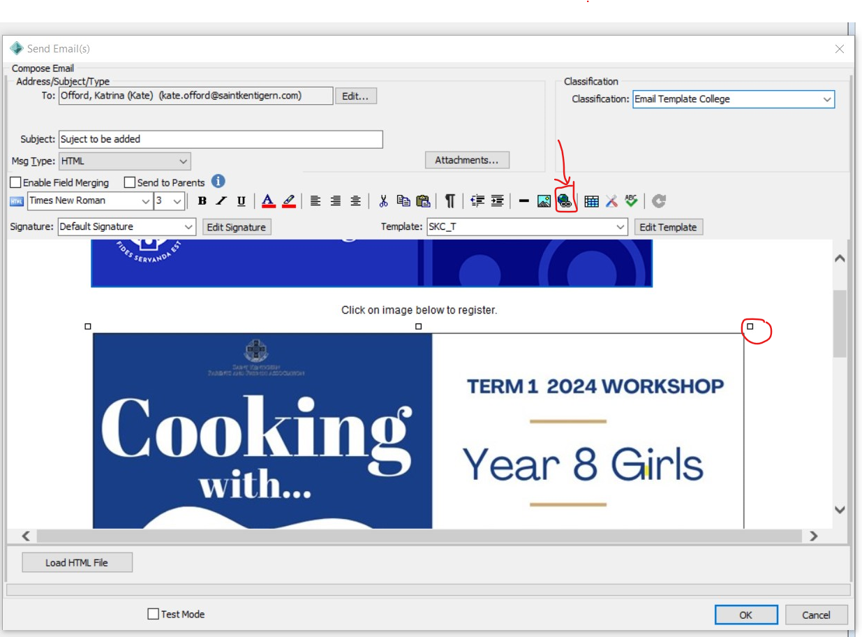 Click on the Hyperlink image.
2. Copy in the hyperlink destination onto the URL point in the synergetic email

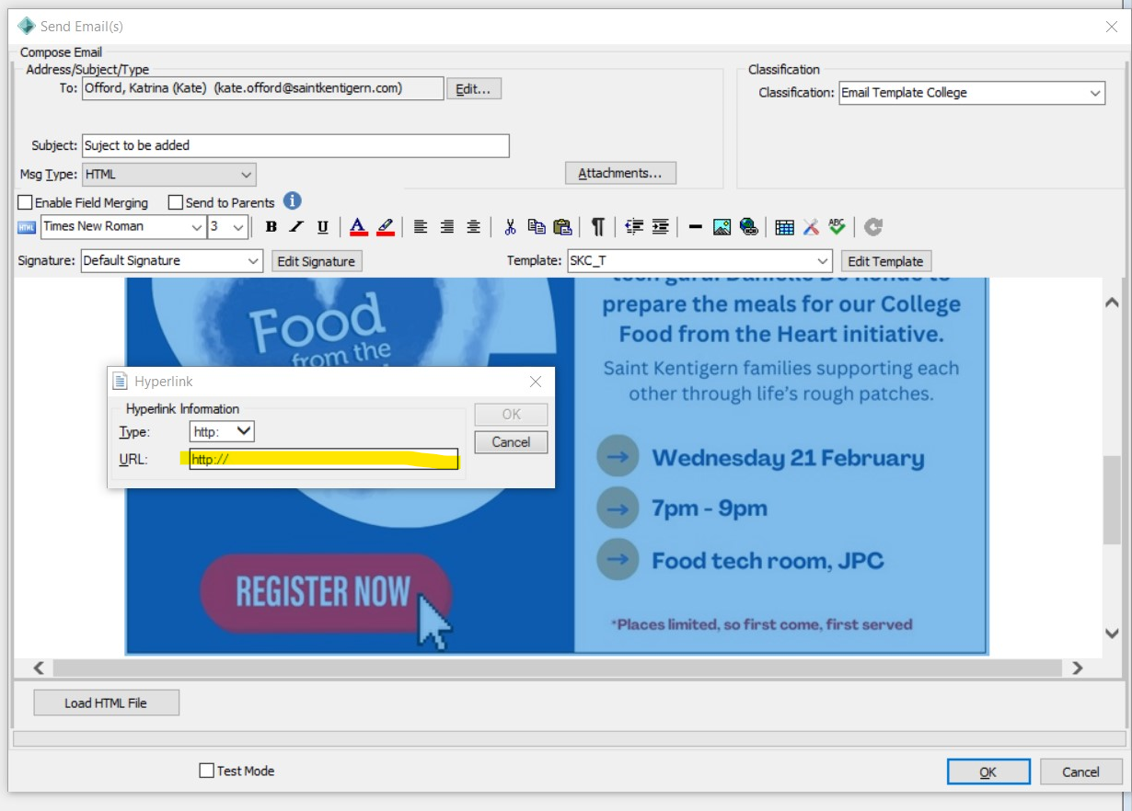

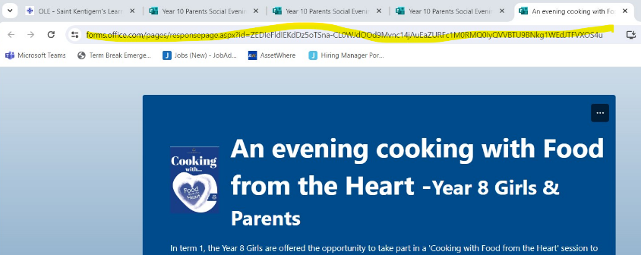

The email is ready to send.

Dear Parents and Caregivers of our College Year 7 Girls,

Please click on the image below to register for the Parent and Daughter Cooking Evening.