May 2026

Dear Parents and Caregivers

This year, the Service Council is helping to run a Year 9 Social that will take place on
Friday 5 June, from 7pm to 9pm in Elliot Hall with all proceeds going to World Vision.

The cost of this event will be $20, which will be automatically charged to your College account if your child attends. On the evening, students will be required to sign in with their ID Cards to confirm attendance. All students need to be in attendance by 7.15pm and are not permitted to leave until the end of the social.

At the conclusion of the evening, we will be releasing students by their House and ask if you can please wait outside Elliot Hall at the end of the evening.

We ask that the students are reminded that they demonstrate the Saint Kentigern Way at this event.

Date: Friday 5 June

Venue: Elliot Hall

Time: 7pm - 9pm (Please wait for your child outside Elliot Hall at the end of the evening)

We hope your child can attend this exciting event. If you have any questions or concerns, please do not hesitate to contact us.

Yours sincerely
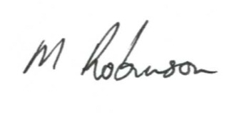
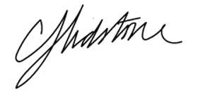
Mark Robinson Carl Lidstone
Service Co-ordinator Deputy Principal – Pastoral Care Middle School

