

Dear Parents and Caregivers of Year 13 Students,

Each year we offer our Saint Kentigern College Year 13 Leavers’ the opportunity to purchase mementos of their time at the College. The items that are available are shown in this document.

Please discuss with your child any purchases they may want to make – an online form will be sent directly to Year 13 students to select hoodie size and advise nick name to be printed on the back. Students can come to Mungos to try on jewellery and get finger sized for the rings. If you do not want your child to make a purchase please email [vanessa.mcsaveney@saintkentigern.com](mailto:vanessa.mcsaveney@saintkentigern.com) by return email.

**Wednesday 28 June 2023 is the cut-off date for orders.**

The jewellery and the hoodies will be available to students at the Leavers’ Luncheon in November. The items purchased will be charged onto their student account providing their account is up to date. Any students with accounts in arrears will need to pre-pay prior to the Leavers’ Lunch, in order for them to uplift the item on the day.

Kind regards,

Vanessa McSaveney  
**Mungo’s Uniform Shop**

 Phone + 64 9 577 0746     
Email [vanessa.mcsaveney@saintkentigern.com](mailto:vanessa.mcsaveney@saintkentigern.com)  
 Web [www.saintkentigern.com](http://www.saintkentigern.com/) |  Post PO Box 51060, Pakuranga, Manukau 2140



**Leavers’ Hoodie $88**

Front View

**Leavers’ Hoodie $88**

Rear View

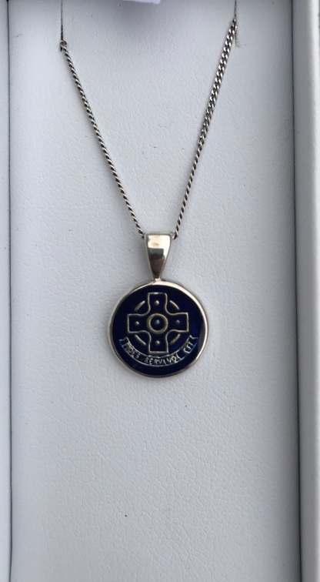

**Sterling Leavers’ Pendant $75.00**

“23” engraved on back

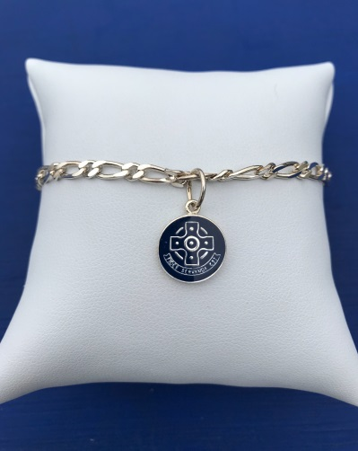

**Sterling Leavers’ Bracelet $94.00  
(Charm only $49.00)**

“23” engraved on back

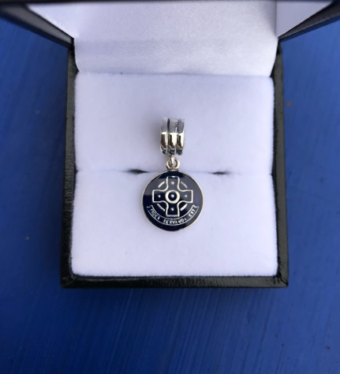

**Sterling Leaver Slider Charm $52.00**

“23” engraved on back

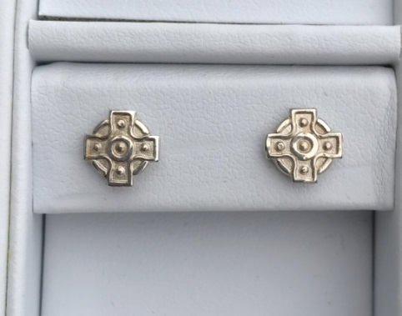

**Sterling Leaver Stud Earrings $36.00**

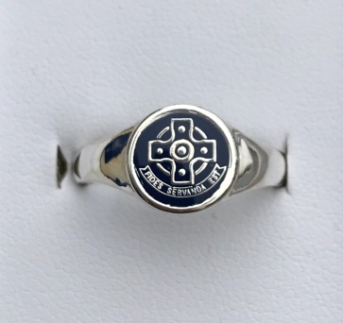

**Sterling Ladies Leavers’ Ring Enamel $88.00**

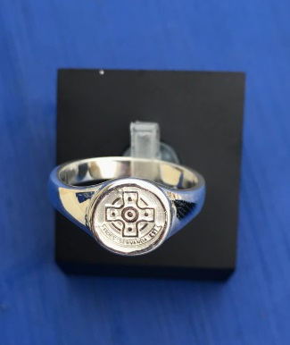

**Sterling Ladies Leavers’ Ring Embossed $82.00**

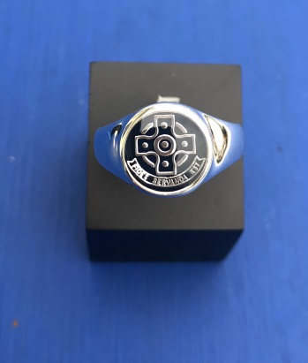

**Sterling Gents Leavers’ Ring Enamel $129.00**

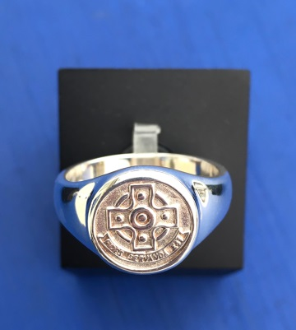

**Sterling Gents Leavers’ Ring Embossed $101.00**

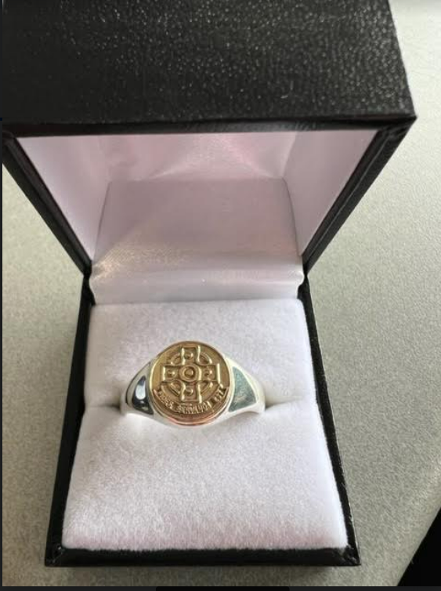

**Sterling/9CT Gents Leavers’ Ring Embossed $435.00**

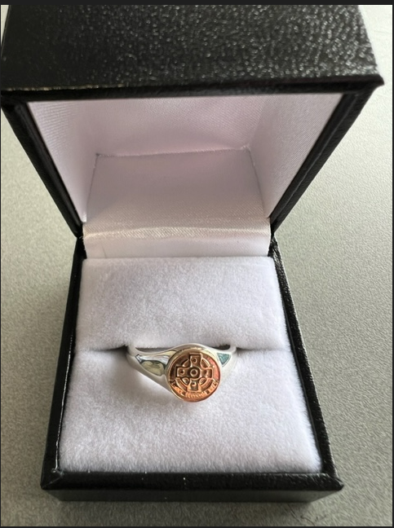

**Sterling/9CT Ladies Leavers’ Ring Embossed $285.00**

**9ct Gold Rings and earrings are available - POA**