19 January 2023

Dear Parents and Caregivers,

As Term 1 approaches, it is timely to welcome new and existing students to a new academic year at Saint Kentigern College. We hope your child has had a refreshing holiday break and is looking forward to a year of growth and fulfilment ahead.

Please see attached the[**Term 1 Term Card**](https://pub.saintkentigern.com/files/College/20230109_Term1_TermCard_College_Calendar2023.pdf), which can also be found on the College OLE**.**

**For your information:**

|  |  |  |
| --- | --- | --- |
| Tuesday 31 January | Year 7 – 13 First day of School | Buses will run on their usual routes. The [bus routes](https://www.saintkentigern.com/about-us/bus-routes/) can be found on the Saint Kentigern website.  The bell will ring at 8.40 am and all students are to move to the following venues. Heads of House and staff will assist.   * **All Year 7** go **to Elizabeth Macfarlan Centre (EMC) Playground.** See attached plan. * **Existing Year 8** to **designated place in Gym 2.** * **All new Year 8** to **EMC Playground.** See attached plan. * **Year 9** all go to **Bruce House Tennis Courts.** * **Year 10** to **designated area** in **Gym 1 & Gym 2.** * **Year 11** to **designated area** in **Gym 1.** * **Year 12** to **designated area** in **Gym 2.** * **Year 13** to **designated area** in **Gym 1.** * **Full** **summer uniform** on **Day 1**. * Normal teaching will begin Period 4. * Bring PE gear (shirt and shorts) on Day 1. * School finishes at **3.30pm** and buses will run as normal. |

**Parent Handbook**

Please take the time to familiarise yourselves and your child with the College policies before the College year commences, and ensure your child is familiar with the content.  [They](https://pub.saintkentigern.com/files/College/20220113_College_Parents_Handbook_2022.pdf) can be found within the [Saint Kentigern College Parent and Caregiver Handbook 2023](https://pub.saintkentigern.com/files/College/20230109_CollegeParentHandbook_2023.pdf), which can also be found on the College OLE.

**Stationery**

It is important that students have all their stationery on their first day at school. Refer to **Office Max**, **My School** via [www.myschool.co.nz](http://www.myschool.co.nz) or email [enquiry@myschool.co.nz](mailto:enquiry@myschool.co.nz).

**Absence for sickness, or unavoidable appointments during the school day**, can be advised by Text: 021 172 6464 or email [skc_absence@saintkentigern.com](mailto:skc_absence@saintkentigern.com). Provide the student’s full name, timeframe of absence, and reason for absence.

**Buses** – please check carefully for route changes on the [Saint Kentigern website.](https://www.saintkentigern.com/about-us/bus-routes/) Students are to catch the bus they have identified as the correct bus. All students may use the College buses for the first week of Term 1 to ensure the bus works logistically for their family.  Forms will then be sent to families to register their child/ren for the bus service. In Week 3 a check will be made to see which buses students are travelling on and families will be billed accordingly. Bus fees are charged each Term to your College account.  A discount may apply if the buses are not used every day.

**Uniform Reminder**

All students are to be in full summer uniform from their first day at school. Full uniform requirements <https://www.saintkentigern.com/about-us/our-uniform/> Click on Saint Kentigern Uniform Shop and then Click on College (SKC).  A reminder that **no** makeup is to be worn and **girls only** are permitted to wear a gold or silver 3 mm stud in their ear lobe only. Boys clean shaven.  Wrist watches are permitted.  Hair is to be of a **natural colour** **and style** and **off the collar, face, and ears**.  Boys need to wear garters with socks if not wearing sandals.

**Mungo’s Uniform Shop**

Mungo’s Uniform Shop is relocating to the **Principal’s House** (next to the Chapel).  Mungos will be open from **Friday 20 January 2023** in their new location. Parking in the visitor carparks in front of the main building currently. We would encourage you to order online for any new uniform/replacement items you may require for the start of Term 1 to avoid queues onsite.

As part of the Mungo’s Uniform Shop relocation and transition period, we are unfortunately **not** able to offer second-hand clothing for purchase or to accept it back for resale until **Term 2, 2023**.

Please go to <https://shop.saintkentigern.com/> and **click SKC (College)** to begin your order. This will enable an efficient turnaround and we believe provide a better and more efficient customer service.

**Option Subject Changes Year 7 to Year 10**

Any requests to change an option subject must be made by a parent on behalf of their child before the end of Friday 10 February. Please contact your child’s Head of House to assist with the option change process. While we do our best to accommodate requests, each one is dependent on current class sizes and possibilities of the timetable.  If you have any questions regarding your child’s core class placement, please contact Natalie Burridge at [natalie.burridge@saintkentigern.com](mailto:natalie.burridge@saintkentigern.com) to assist you with your enquiries.

**Course Change Afternoons Year 11 to Year 13**

Over the summer break, your child may have had second thoughts about their subject selection for 2023.  Please refer to communication from Deputy Principal Mrs Robertson sent via email and OLE Notices on 16 January regarding this process and the two Course Change afternoons next **Monday 23 January and Tuesday 24 January from 3.30pm – 5.00pm** in the **Year 13 Common Room**.

We look forward to seeing all College students on their starting day and trust this information will help your child begin the year smoothly.

Yours sincerely,



Damon Emtage

**COLLEGE PRINCIPAL**

**Important Dates**

In preparation for the year ahead, we would like to remind you of some important dates in the first few weeks of the 2023 calendar:

| **Date** | **Event** | **Information** |
| --- | --- | --- |
| Monday 23 January  Tuesday 24 January | Course Changes  (**Year 11 to Year 13**) | **3.30pm – 5.00pm,** Year 13 Common Room. |
| Monday 23 January | Girls Prefect Uniform Fittings | **Girls – 3.00pm** Mungos (while on camp) |
| Wednesday 25 January | Boys Prefect Uniform Fittings | **Boys – 9.00am** Music Centre |
| Monday 23 - Wed 25 January | Prefect Leadership Camp | **9.00am** Meet at Bruce House  **9.00am finish on Wednesday 25 January** |
| Monday 23 January & Tuesday 24 January | Peer Support Leaders Training | **(M) 10.00am – 3.30pm** in the Music Centre  **(T) 9.00am – 3.30pm** in the Music Centre |
| Wednesday 25 January | Year 11 Mentors Only | **8.50am** start – Gym 1 |
| Wednesday 25 January | Year 12 IB Induction Day | **9.00am** Goodfellow Centre |
| Wednesday 25 January | New International Students Orientation Day | **12 noon midday** |
| Thursday 26 January | New Students Orientation (Years 10 to 13) | **10.00am** Goodfellow Centre – **House Leaders are required to attend.** |
| **Tuesday 31 January** | **Year 7 – 13**  **First day of School** | Buses will run on their usual routes.  Bell will ring at 8.40 am and all students need to move to the following venues. Staff will assist.   * **All Year 7** to **Elizabeth MacFarlan Centre (EMC) Playground –** See attached plan. * **Existing Year 8 Gym 2.** * **All new Year 8** to **EMC Playground -** See attached plan. * **Year 9** all to **Bruce House Tennis Courts.** * **Year 10 Gym 1 & 2** designated seating. * **Year 11** **Gym 1.** * **Year 12** **Gym 2.** * **Year 13** **Gym 1.** * **Full** **summer uniform** on **Day 1**. * Normal teaching will begin Period 4. * Bring PE gear (shirt and shorts) on Day 1. * School finishes 3.30pm, buses will run as normal with assistance for new students. |
| Tuesday 31 January | Prefect Commissioning Service for Year 13 Prefects and their families only. | **5.30pm – 7.00pm** Chapel and Goodfellow Centre for Refreshments and Photos |
| Friday 3 February | Formal Assembly  **Tutor Group** & **Individual Photographs** | 12.30pm Gym 1 - **Formal Uniform** |
| Sunday 5 February | Bruce House Chapel | **7pm** |

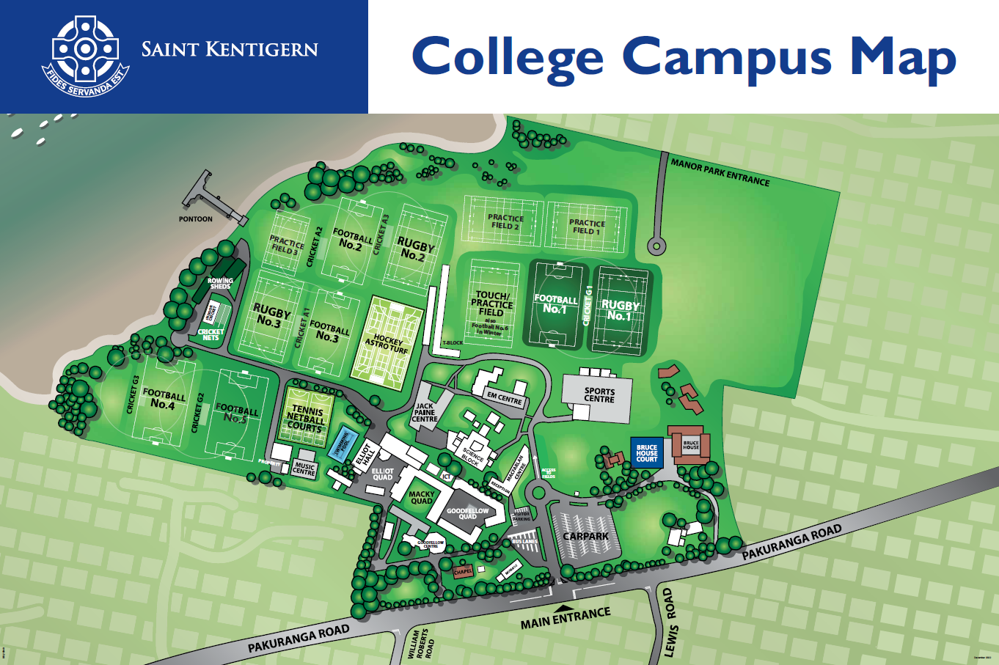

**BH Tennis Courts**

**EMC Playground**