Parents and Friends of Saint Kentigern College invite you to

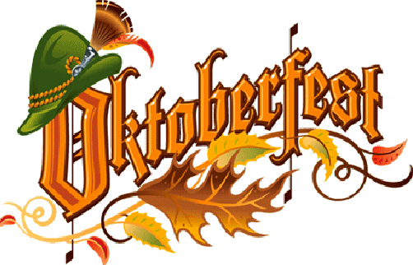

Join us for a night of fun with your friends
Music from the Dalewool Auckland Brass Bavarian Band


Dress: Smart Casual or Bavarian
Bring your own Stein and enjoy a night of entertainment!

7.30-11.30pm

Saturday October 30th
Elliott Hall, Saint Kentigern College
130 Pakuranga Road, Pakuranga

$45 a head includes first drink, nibbles and continuous German supper

Oktoberfest Supper Menu

Rye bread, Kaiser rolls & Poppy seed flat bread
with butter

Selection of German Sausages
Sliced Ham platters
Potato salad with fresh herbs & pickles
Sauerkraut
Platters of pickled onions & gherkins
Selection of mustards & chutneys

Black Forest cake
Apple Strudel with Cream

Tea & Coffee

***

Post form to: | Email form to: | Enquiries to:
Parents & Friends Association  Saint Kentigern College  P O Box 51 060  Pakuranga  Manukau | pandf@skc.school.nz | Pippa Styles  (09) 585 1055  021 669 769
Cheques payable to: Parents & Friends Association
- - - - - - - - - - - - - - - - - - - - - - - - - - - - - - - - - - - - - - - - - - - - - - - - - - - - - - - - -

Saint Kentigern College Oktoberfest October 30th 2010

Your name :
Your contact phone no :

Names of attendees :
- -
- -
- -
- -
- -

No. of tickets: x $45.00 = $

Cheque attached: [_]

