Saint Kentigern College Subject Learning Conferences:
Caregiver Login & Booking Instructions

Gmail or Microsoft Email Instructions
Step Two: Sign in with either Microsoft or Google.
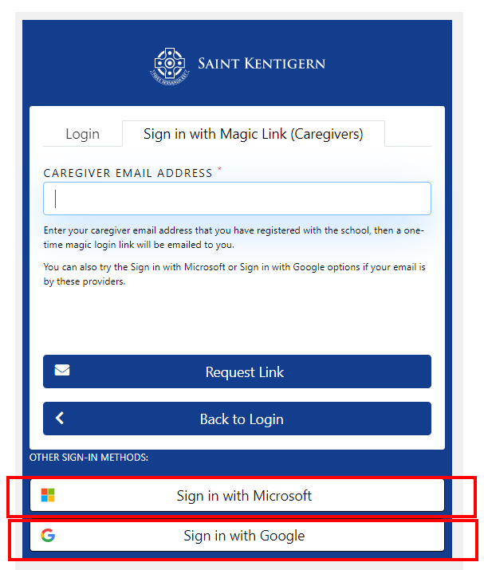
Step Three: Select Your Child Page (Only if you have more than one child at Saint Kentigern College)
- A list of your children will be displayed. Select your child that you wish to book conference time for.
- Please Note: You will need to come back to this page to book conference times for your other children if required
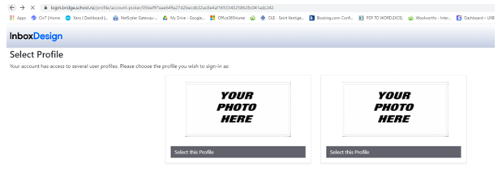

Step Four: Book your Conference Times
Click on the ‘Conferences’ button 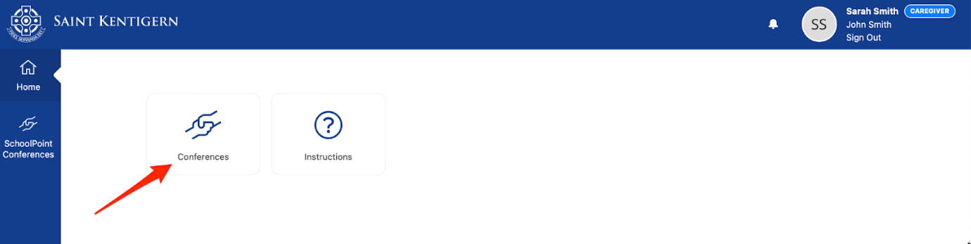
Click on the ‘Book Time’ button
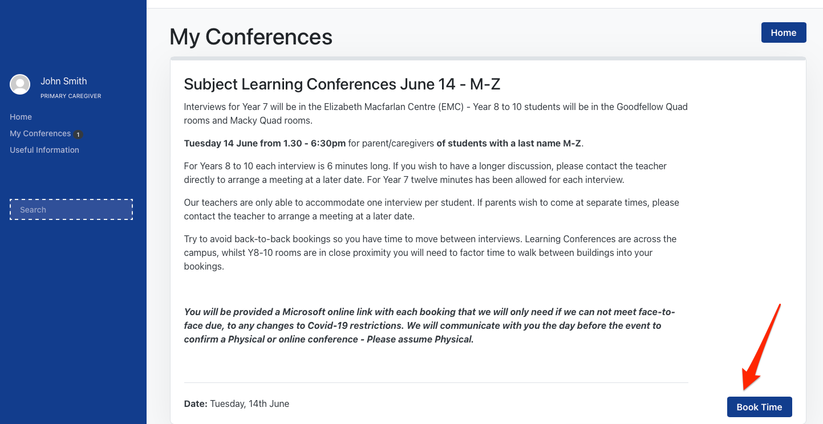

- Select an open booking slot for each of the subject teachers that you would like to see.
- Please leave a gap in between your conference bookings as you will need to allow ‘travel time’ to move to your next conference.
- Once you have selected all your conference times click the ‘Summary’ button
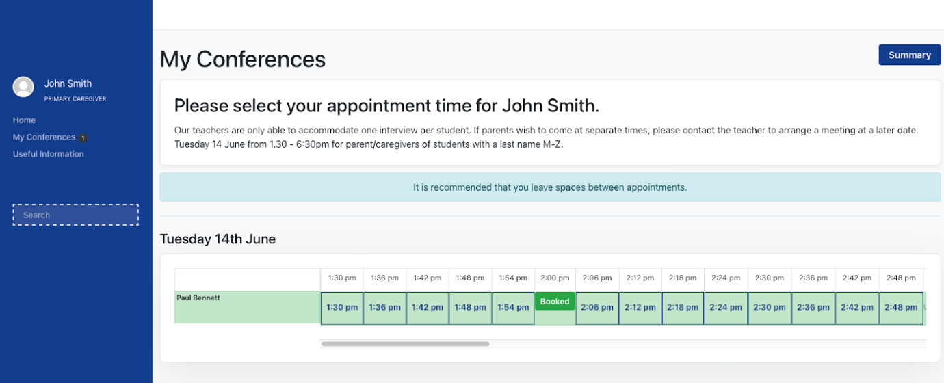
Step Five: Final Check & Adding Comments to Subject Teacher
On this page you can:
- View all your selected conference times
- Add Notes for the Subject Teacher. This function is helpful if you would like to ask specific questions during your conference. The teacher will be able to see this when you make the booking.
- Make changes to your bookings
- Print your bookings (at the bottom of the page)
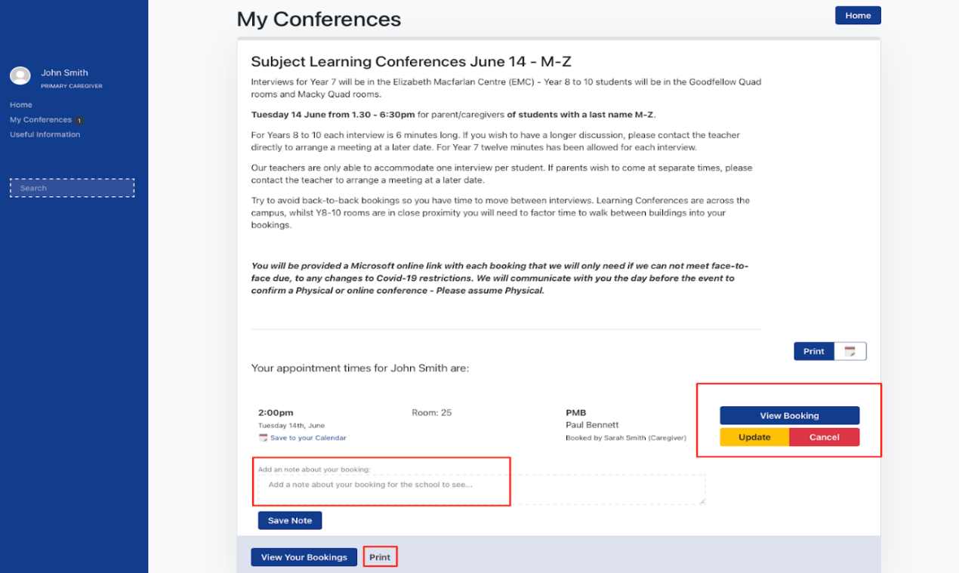
Step Six: Booking Conference Times for Additional Children
If you have multiple children at Saint Kentigern College, you will need to book in conference times for them as well.
- Go back to the ‘Select your Child Page’ You can either go back through your browser by clicking the ‘back’ button until you reach this. Or you can login again.
- Take note of your current bookings to ensure that you do not double book yourself or don’t give yourself enough time to travel to the next booking.

