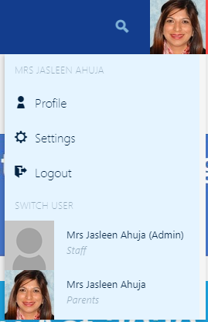**For Staff as parents:**

Log into OLE and then click on your picture, it will come up with a parents profile as shown in the picture, click on it to go into your parent profile.

Now you can follow the below steps to check reports or book a conference.

**For reports (available Thursday 3 June).**

Log on to the OLE ([www.saintkentigern.com](http://www.saintkentigern.com), click on Parent OLE Access and log in with your user name and password).

Select the child you wish to see the report for.

Click on the Report tab, example highlighted in yellow below.

a

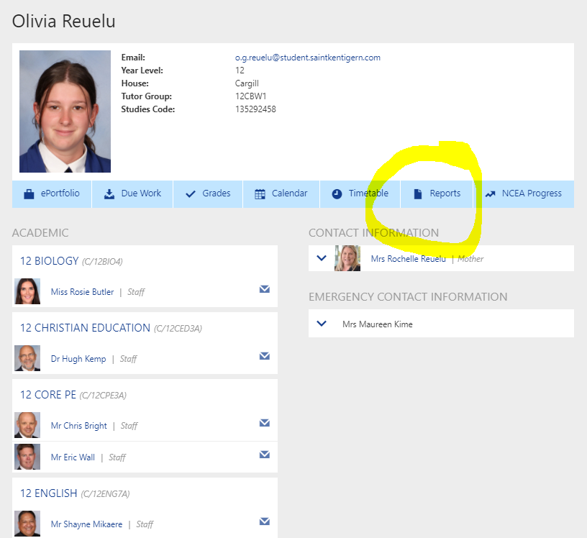

Jane Doe



Mrs Janet Doe



Jane.doe

a

a

a

a

a

a

a

**For Subject Conference Booking (able to be booked Thursday 3 June).**

Log on to the OLE ([www.saintkentigern.com](http://www.saintkentigern.com), click on Parent OLE Access and log in with your user name and password).

Click on the Parent Portal icon as shown:

Then click on the College Interviews tab as shown:

If you wish to have a longer discussion than the timeslot allows for, or the Teacher you wish to see has all the timeslots booked up, please contact the subject teacher directly to make a time on a later date.

*If you have misplaced your login details for the OLE, please use the Parents, ‘forgotten your password’ option below the login fields. When prompted, please enter the email address you provided to the College. Your user name and password will be automatically emailed to you.*