COLLEGE CAMPUS ACCESS - Keeping Our Students Safe

**In the interests of student safety please observe the following:**

**Morning Drop off**

1. No stopping permitted at any time on the main entrance road or the College roundabout.
2. Students may only be dropped off in the first 2 bus lanes or at the Manor Park entrance to the College.
3. Parents dropping off students in cars in the morning, must use the outside lanes 6 and 7 of the Bus Lanes only. The other lanes are for our buses to use.
4. Lane 1 (closest to the Chapel) is used by staff to turn left up past the Chapel. There is no stopping. Students are not to be dropped off up past the Chapel
5. Please follow the directions of duty staff wearing high-viz jackets
6. When leaving the bus lanes, there is no right turn out of Chapel Rd between the hours 8am - 9am.

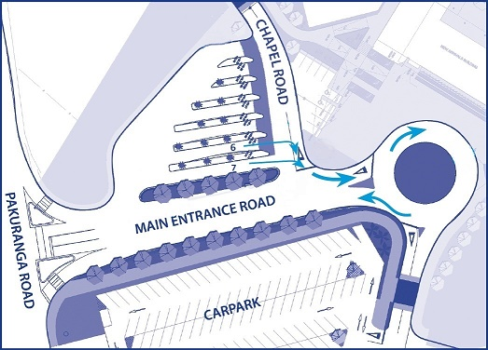

**After School Pick Up**  
Between 3pm and 4pm, 32 buses arrive at and leave the College grounds in short turnaround and the presence of excess vehicles at this time not only puts pressure on departing buses but also compromises the safety of our students. Parents wishing to collect their children by car during this period will need to enter via the Manor Park entrance at the rear of the campus, where parking is available on both sides of the access road and around the roundabout.

Parents should not be collecting students from the staff and student car park.

Please avoid using Grammar School Road as there is limited turning space. There is no entry to or exit from Chapel Rd between 3.20pm & 3.40pm due to bus traffic.

**Please remember:  The speed limit on campus is 20kph at all times on all campus roads.**