

SENIOR SCHOOL GIRLS (Year 11, Year 12, Year 13)

Senior School Summer Blouse |  | Senior School Long Formal/Winter Skirt
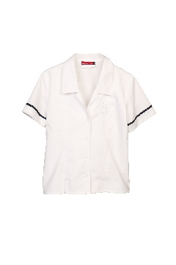 | Sized based on the Middle School grey or pale blue winter blouse. | 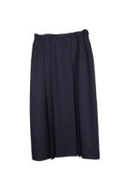 | Sized according to the striped summer skirt for waist size.  This is worn as part of the Formal Uniform and also in winter.
Shoe Liners |  | Senior School Navy Blue Jersey (Unisex)
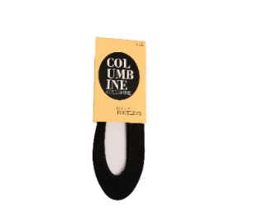 | To be worn in summer with black loafers. | 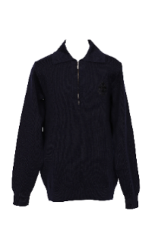 | Sized based on the existing Middle School jersey.
Senior School Loafer
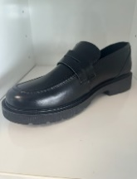
Compulsory for Senior School Girls. Please use size chart to measure foot size in cm.
SENIOR SCHOOL BOYS (Year 11, Year 12, Year 13)

Senior School Summer Shirt |  | Senior School Navy Blue Jersey (Unisex)
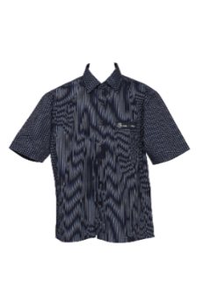 | Sized based on the Middle School grey striped daywear shirt.  If your son is above average height for his age, please order the Tall fit (use the size chart to check the length measurement). | 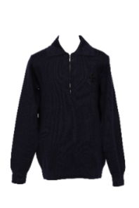 | Sized based on the existing Middle School jersey.
Senior School Sock (woollen or cotton) with navy blue stripe
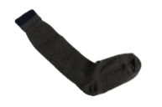
These socks are to be worn with black dress loafers for day wear.

